**Google Cloud Platform:**

Google Cloud Platform provides a series of modular cloud services including computing, [data storage](https://en.wikipedia.org/wiki/Computer_data_storage), [data analytics](https://en.wikipedia.org/wiki/Data_analysis) and [machine learning](https://en.wikipedia.org/wiki/Machine_learning). Google Cloud Platform is a part of **Google Cloud**, which includes the Google Cloud Platform public cloud infrastructure, as well as **G Suite**, enterprise versions of [Android](https://en.wikipedia.org/wiki/Android_(operating_system)) and [Chrome OS](https://en.wikipedia.org/wiki/Chrome_OS), and [application programming interfaces (APIs)](https://en.wikipedia.org/wiki/Application_programming_interface) for [machine learning](https://en.wikipedia.org/wiki/Machine_learning) and enterprise mapping services.

**Domains in Google Cloud Platform:**

**Android MDM with GCP:**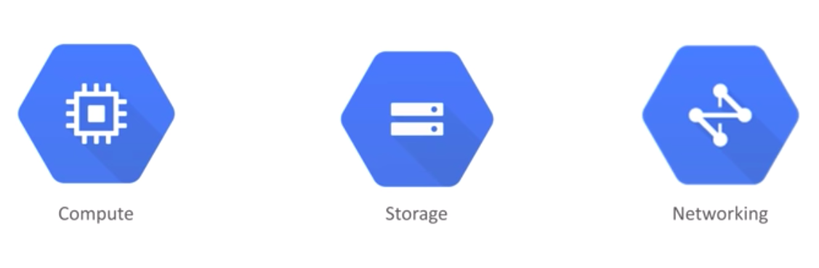

In Android MDM, to manage the android devices and get the notification of new enrollment device, we are using the **Android Management API** and **Cloud Pub/Sub API**. To manage all the API’s we need to create a project and enable the API’s to the project and it can be achieved by **Google Cloud API’s.**

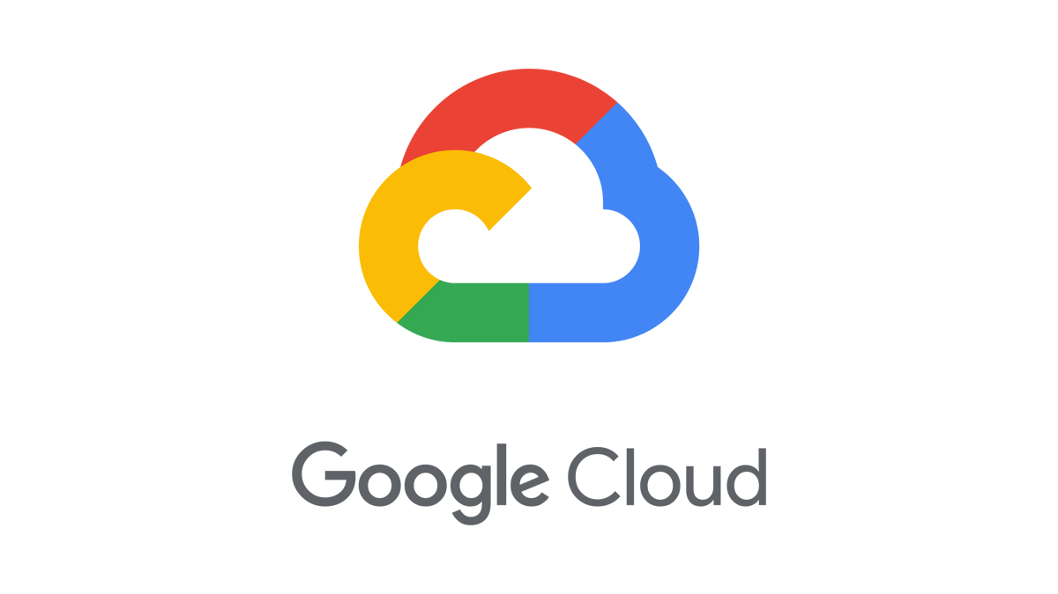



**Android Management API:**

Android Management API supports the full enterprise mobility management lifecycle, from initial customer enrollment to setting up and managing devices. Our console uses the Android Management API to create enrollment tokens, policies, and other management resources. During enrollment, each device installs the API's companion app, [Android Device Policy](https://play.google.com/store/apps/details?id=com.google.android.apps.work.clouddpc).

For complete setup of android Management API follow the below steps,

**Step 1: Enable the Android Management API**

Enable the Android Management API for your project.

1. Sign in to the Google API Console.
2. Select or create a project.  
   [GCP Project Page](https://console.cloud.google.com/project)
3. Click Enable API.
4. Search for and select Android Management API in the API library.  
   [API Library Page](https://console.cloud.google.com/apis/library)
5. Click Enable.

**Step 2: Create your service account**

1. Sign in to the Google API Console.
2. Open the [credential Page.](https://console.developers.google.com/project/_/apiui/credential) Select the project that has the Android Management API enabled.
3. Click Create credentials > Service account key.
4. From the dropdown menu, select New service account. Enter a name for your service account.
5. Select your preferred key type and click Create. Your new public/private key pair is generated and downloaded to your machine and is the only copy of this key. You are responsible for storing it securely.
6. (Optional, but highly recommended) Add additional project owners by [granting the owner role](https://cloud.google.com/iam/docs/managing-policies#access_control_via_console) to existing project members.

Note: Service Account JSON/other files is used to connect our EMM server and google API’s.

We use this service account token for authentication purpose and to avoid simultaneous login.

**Cloud Pub/Sub API**:

Pub/Sub is a fully-managed real-time messaging service that allows you to send and receive messages between independent applications.

For complete setup of Cloud Pub/sub API follow the below steps,

**Step 1: Enable the Pub/Sub API for your project**

Ensure that you select the same project that the Android Management API is enabled.

1. Sign in to the Google API Console.
2. Select or create a project.  
   [GCP Project Page](https://console.cloud.google.com/project)
3. Click Enable API.
4. Search for and select Pub/SubAPI in the API library.  
   [API Library Page](https://console.cloud.google.com/apis/library)
5. Click Enable.

**Step 2: Create a topic**

After enabling the API, you need to create a topic that Android Device Policy can publish notifications to.

1. Go to the Pub/Sub topics page in the Cloud Console. [Pub/Sub topics page](https://console.cloud.google.com/cloudpubsub/topicList?_ga=2.105682688.2078749904.1580341751-2061102630.1577925017)
2. Click **Create a topic**.
3. Enter a unique **Name** for your topic, for example, MyTopic.

That's it—you've just created a Pub/Sub topic!

**Step 3: Create a subscription**

A subscription captures the stream of messages published to a given topic.

1. Display the menu for the topic you just created, and click **New subscription**.
2. Type a name for the subscription, such as *MySub*.
3. Leave the delivery type as **Pull**.
4. Click **Create**.

**Step 4: Grant Android Device Policy the right to publish to your topic**

You need to give android-cloud-policy@system.gserviceaccount.com permission to publish to your topic.

To set access controls at the project level:

1. Open the [Cloud IAM page](https://console.cloud.google.com/project/_/iam-admin/iam?_ga=2.81246228.2078749904.1580341751-2061102630.1577925017) in the Cloud Console.
2. Select your project, and click **Continue**.
3. Click **Add Member**.
4. Enter the email address of a new member to whom you have not granted any Cloud IAM role previously.
5. Select a role from the drop-down menu.
6. Click Add.
7. Verify that the member is listed under the role that you granted.

To set access controls for topics and subscriptions:

1. Navigate to the [Pub/Sub topics page](https://console.cloud.google.com/project/_/cloudpubsub/topic/list) in the console.
2. Select your Pub/Sub-enabled project.
3. Select the topic or subscription.  
   You can set permissions for multiple topics at one time. To set permissions for a topic's subscription, expand the topic and click the subscription to open it in its own page.
4. Click **Permissions**. In the pane that appears:
   1. Type in a member name or names.
   2. Select a role from the drop-down menu.
   3. Click **Add**.